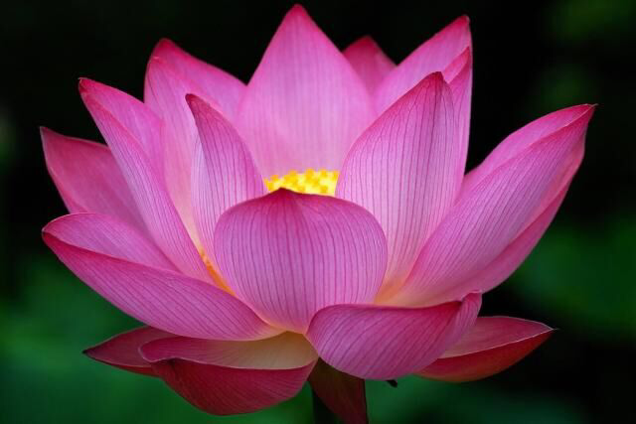

Staying in Balance
with
Bonnie Diamond, Licensed Acupuncturist

www.bonniediamond.com • 781-718-6325 • health@bonniediamond.com

Individualized
Heart-Centered Care
Tracking Glimmers – Create a list of moments when you feel at peace, a sense of ease, something miraculous about the world. Use this list as a reminder that things there is still joy in the world even in the midst of pain, fear and uncertainty.

Examples of glimmers are noticing the sun shining, the feel of a warm bath, hearing your favorite song, petting your pet, noticing a plant or tree, feeling the air on your skin…

Date Glimmer

__________ _____________________________________________________________________________________________

__________ _____________________________________________________________________________________________

__________ _____________________________________________________________________________________________

__________ _____________________________________________________________________________________________

__________ _____________________________________________________________________________________________

__________ _____________________________________________________________________________________________

__________ _____________________________________________________________________________________________

__________ _____________________________________________________________________________________________

__________ _____________________________________________________________________________________________

__________ _____________________________________________________________________________________________

__________ _____________________________________________________________________________________________

__________ _____________________________________________________________________________________________

__________ _____________________________________________________________________________________________

__________ _____________________________________________________________________________________________

__________ _____________________________________________________________________________________________

__________ _____________________________________________________________________________________________

__________ _____________________________________________________________________________________________

__________ _____________________________________________________________________________________________

__________ _____________________________________________________________________________________________

Need some encouragement? Just email health@bonniediamond.com, and together we'll put you on the path to health!

